Revision History
Date | Version | Description | Author
<dd/mmm/yy> | <x.x> | <details> | <name>
11.03.2014 | 1.0 | Details about Android added | Pamir Çevikoğulları
11.03.2014 | 1.0 | To write overview of phases and its subparts | Pamir Çevikoğulları
11.03.2014 | 1.1 | Details about database design and implementation | Begüm Tokuyucu
11.03.2014 | 1.1 | To list all risk and their strategies and indicators about the project. | Begüm Tokuyucu
11.03.2014 | 1.1 | To fix the references section. | Begüm Tokuyucu
11.03.2014 | 1.2 | To specify the responsibilities. | Oğuz Gelal
11.03.2014 | 1.2 | Details about web tools added. | Oğuz Gelal
11.03.2014 | 1.2 | To add abbreviations. | Oğuz Gelal
11.03.2014 | 1.3 | Details about software development tools and process added. | Elvin Şenoymak
11.03.2014 | 1.3 | To write code rules and standards. | Elvin Şenoymak
11.03.2014 | 1.3 | To add configuration management tool. | Elvin Şenoymak
11.03.2014 | 1.4 | Details about iOS added | Turushan Aktay
11.03.2014 | 1.4 | Draws the charts | Turushan Aktay

TABLE OF CONTENTS

Revision History 1
1 Identification 3
1.1 Document overview 3
1.2 Abbreviations 3
1.3 References 3
1.3.1 Project References 3
2 Software Development Activities 3
2.1 Software development process 3
2.1.1 Overview of process phases 3
2.1.2 Technical documentation 4
2.1.3 5
2.1.4 Deliverables: 5
2.2 Software development tools 5
2.2.1 Workstation 5
2.2.2 Requirements management and documentation 5
2.2.3 Software Design 5
2.2.4 Coding and automated tests 5
2.2.5 Configuration management 6
2.3 Software development rules and standards 6
3 Responsibilities 7
3.1 Activities and responsibilities 7
4 Risk Assessment 9
4.1 Risk Analysis 9
4.2 Risk Planning 10

Identification

Document overview
This document contains the software development plan of software ÇetinApp.

Abbreviations
- SDK : Software Development Kit
- iOS: Iphone Operating System
- SDP: Software Development Plan
- SRS: Software Requirements Specification
- STP: Software Test Plan
- SDD: Software Design Document
- STR: Software Test Report
- IDE: Integrated Development Environment
- UML: Unified Modeling Languages
- OS: Operating Systems
- MySQL: My Structed Query Language
- API: Application Programming Interface

References

Project References

The first document does not have any references.

Software Development Activities
The section lists and describes the software development activities of ÇetinApp software development project.

Software development process
The waterfall programming model was chosen for ÇetinApp. One of the reason is; because we are dividing a whole project into five and each group member has strict responsibilities, we felt a need to determine who will do what, how will they do it and when will they do it. Another reason is that this application is our own project so that we know what we will do and how we will implement it from the beginning. Planning ahead and documenting will speed up the process. Yet another reason why we chose waterfall is that we are building an application that uses one common database which may cause problems due to standardizations. For that reason, we wanted to identify and analyse the possible risks that we might encounter.

Overview of process phases
- Project Planning
- Requirement Analysis
- Software Test Planning
- Software Design Documentation
- Implementation
  - Android Application Front-end
  - Android Application Back-end
  - iOS Application Front-end
  - iOS Application Back-end
  - Web Application Front-end
  - Web Application Back-end
  - Application Database (MySQL)
- Unit Testing
- Software Test Report

This is an activity chart that shows our process in terms of times.

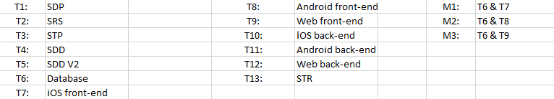

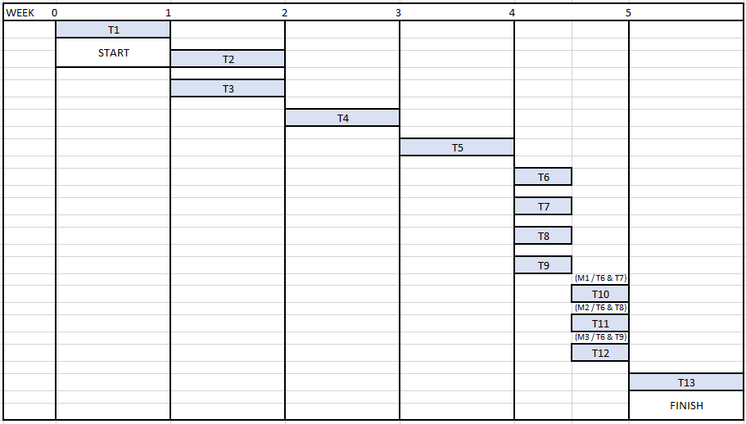

Technical documentation
The following documentation is produced during the design phases:

- Software development plan (SDP)
- Software specifications: SRS, STP
- Software detailed conception: updated SRS, SDD, STP.
- Coding and unit tests: STR of unit tests
- Software tests phases: STR.

Deliverables:
- Application files;
  - Android application (.apk)
  - iOS Project File (.xcodeproj)
  - Web application (.html .css .js .php)
  - Database design (UML) and implementation (.sql)
- Documentation;
  - Technical documentation (SDP, SRS, STP, SDD, STR)
  - User guide that explains administration and installation procedure.
  - README file for usage of application
- Github records;
  - Project page
  - Bugs and issues
  - Time tracking, contributions, commit history

Software development tools

Workstation
- Mac OS 10.9
- Linux – Ubuntu
- Windows 8

Requirements management and documentation

- Software Design GitHub for documentation commits
- Google Docs for documentation preperation
- Microsoft Excel for gannt charts

Software Design

- Argo UML : UML Diagram Generator for Java
- Creately UML Diagram Builder: Web-based UML builder for MySQL.
- OmniGraffle: is built only for Mac OS X and the iPad, may be used to create diagrams, flow charts, org charts, and illustrations.

Coding and automated tests

- Coding Tools;
  - IntelliJ IDEA: Java IDE by JetBrains.
  - Android SDK: Process by which new applications are created for the Android operating system
  - Xcode: An integrated IDE for OS X and iOS.
  - Sublime Text 2: Text editor
  - phpMyAdmin : MySQL management interface for database design and implementation

- Bugs Tools;
  - LogCat for Android: Stores a log of system debug output and show errors which are thrown by system.
  - JetBrains PhpStorm XDebug : Web Application Debugger.
  - Xcode: an integrated IDE for OS X and iOS, its debugger will be used for debugging.
  - iOS Simulator: Simulates app on virtual device, will be used for early testing.
  - Instruments (Xray): Performance analyzer and visualizer integrated to Xcode, will be used for deep testing like memory leaks etc.

- Unit Testing Tools
  - JUnit: Unit testing on a class that doesn't call Android APIs
  - MyTAP: Unit testing tools for mysql scripts
  - JetBrains PhpStorm Testing : Unit testing tools for web applications
  - Xcode XCTest Framework: Unit tester for iOS.

Configuration management

- Github: Web based hosting and revision control service for software development projects.

Software development rules and standards

- Standards

  - UNIX Timestamp will be used for time management
- Coding rules

  - Camel notation will be used for variable method and class names. (src:)
  - Meaningful names will be given.
  - Classes will have private fields and will be modified with getter-setter methods.
  - Methods will do only one thing and will be refactored as much as possible.

Responsibilities

There is a one project manager and tasks of project assigned each people according his or her qualifications. On the other hand, each assignment should have more than one person.

Activities and responsibilities

Activity | Responsibility | Comment
Project Manager | Oğuz Gelal | Responsible for project progress and making sure that project should finish in a timely manner.
Configuration tools management | Oğuz Gelal  Pamir Çevikoğulları  Turushan Aktay  Begüm Tokuyucu  Elvin Ege Şenoymak | All the team members are responsible from their own configuration tools.
Setting up the Development tools | Pamir Çevikoğulları | Pamir is admin of the Github account of the project. In general everybody will set up their own tools
Web (Front-end) | Elvin Ege Şenoymak | Responsible for building the web interface.
Web (Back-end) | Oğuz Gelal | Responsible for database connections and programming the web application
Database design and implementation | Begüm Tokuyucu | Responsible for drawing and creating MySQL database.
Android Developer | Pamir Çevikoğulları | Implements the android application of ÇetinApp
iOS Developer | Turushan Aktay | Implements the iOS application of the ÇetinApp
Risk Analysists | Begüm Tokuyucu, Oğuz Gelal | Lists all predictable risk of project.
Tester | Oğuz Gelal  Pamir Çevikoğulları  Turushan Aktay  Begüm Tokuyucu  Elvin Ege Şenoymak | Everyone will test their own product with their own unit test tool.
Documentation | Oğuz Gelal  Pamir Çevikoğulları  Turushan Aktay  Begüm Tokuyucu  Elvin Ege Şenoymak | Everyone will contribute to the documentation explaining their own part.

This is a staff allocation chart that indicates each people is responsible of which part of project in terms of times.

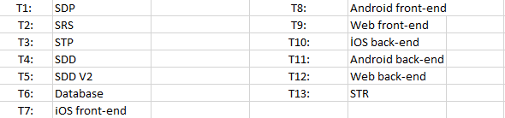

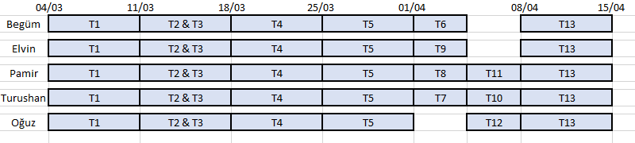

Risk Assessment

Risk Analysis

Risk | Probability | Effects
The time required to develop the software is underestimated. | High | Serious
The complexity of the software is underestimated. | High | Tolerable
The repair time of defect repair is underestimated. | Moderate | Serious
Software in different platforms cannot work together in an integrated way. | Moderate | Tolerable
One of the people will drop to course. | Moderate | Tolerable
Project turn out to be more challenging. | High | Serious
Key staff are ill and unavailable at critical times. | High | Serious
Running out of database space | Moderate | Serious
Server traffic could be inadequate. | High | Serious
Newer versions could mobile OS’s could not support certain components that is being used. | High | Moderate
Different browsers may not support some functionalities (for web) | High | Moderate
Non-responsive designs could fail in different screens (for Android and Web) | High | Moderate

Risk Planning

4.2.1 Risk Strategy

Risk | Strategy
The time required to develop the software is underestimated. | We will spend more time trying to complete the project.
The complexity of the software is underestimated. | We will find a way to make it work in a simpler manner.
The repair time of defect repair is underestimated. | We will find another way to solve the problem.
Software in different platforms cannot work together in an integrated way. | We will find a way around the problematic software so that we could go on without using it.
One of the people will withdraw the course. | We will be able to replace each other.
Project turn out to be more challenging. | We will spend more hours to complete the project.
Key staff are ill and unavailable at critical times. | We will inform eachother about critical points in a way that we could replace eachother.
Running out of database space. | Upgrade the database plan.
Server traffic could be inadequate. | Upgrade the hosting plan.
Newer versions could mobile OS’s could not support certain components that is being used. | Problem will be fixed with an update.
Different browsers may not support some functionalities (for web) | Other functionalities would be used for those functionalities.
Non-responsive designs could fail in different screens (for Android and Web) | Non-responsive components of the design will be replaced.

4.2.2 Risk Potential Indicators
Risk | Potential Indicators
The time required to develop the software is underestimated. | If we have much more to do in a short time.
The complexity of the software is underestimated. | In case of a problem, if we can’t figure out where it is.
The repair time of defect repair is underestimated. | If we can’t keep up with our schedule because of a problem.
Software in different platforms cannot work together in an integrated way. | Software of one of the platforms fail to connect to the database.
One of the people will withdraw the course. | If our group member fails to attempt to our meetings and ignores us.
Project turn out to be more challenging. | If we figure out technical process is not as we though and we fall behind our schedule.
Key staff are ill and unavailable at critical times. | If our group member fails to attempt to our meetings and ignores us.
Running out of database space. | Receive error stating the database space is full.
Server traffic could be inadequate. | Receive error from the server stating that the traffic is inadequate.
Newer versions could mobile OS’s could not support certain components that is being used. | If some functionalities does not work after an OS update
Different browsers may not support some functionalities (for web) | If some functions does not work across different browsers.
Non-responsive designs could fail in different screens (for Android and Web) | If some design components fails to work properly

